
Sukkur Institute of Business Administration University
Department of Computer Science

Programming Fundamentals (C++)

BS – I (Computer Science - D)

Fall 2025

Instructor: Nisar Ahmed Siddiqui

LAB # 01

Submission Profile

Name: Abdul Wasio
CMS ID: 023 - 25 - 0007
Date: 12th September 2025
Receiving Authority: Sir Nisar Ahmed Siddiqui

PROGRAMMING FUNDAMENTALS
TABLE OF CONTENTS
03-07
Activities
08
Exercise 1
09
Exercise 2

10
Exercise 3 & 4

11
Exercise 5

12
Exercise 6
14
Exercise 7 & 8

16

Exercise 9 & 10

Activity 1
Write a C++ program that prints/displays your name on the screen.

Program
#include<iostream>
using namespace std;
int main(){
cout<<"My First Name is Abdul"<<endl;
cout<<"My Middle Name is Wasio"<<endl;
cout<<"My Last Name is Shaikh"<<endl;
system("pause");
return 0;
}
Output:
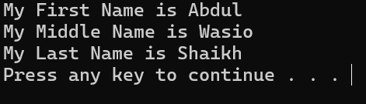

Activity 2
Write a C++ program that prints your details, like name, student ID, batch and the department, each on a separate line.

Program
#include <iostream>
using namespace std;
int main(){
cout<<"Name: Abdul Wasio Shaikh";
cout<<"\nF'Name: Abdul Hameed Shaikh";
cout<<"\nNumber: 03243051146";
cout<<"\nGender: M";
cout<<"\nAge: 18";
cout<<"\nEdu: Studying BSCS at SIBAU";
cout<<"\nSection: D";
cout<<"\nCMS ID: 023 - 25 - 0007\n";
system("pause");
return 0;
}
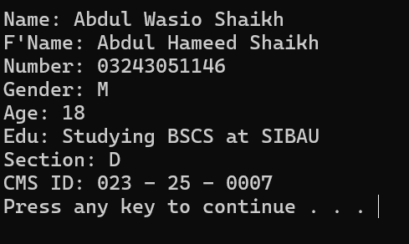
Output

Activity 3
Write a C++ program to print numbers from 1 to N (where N is the number of characters in your first name) on the same line with each pair of adjacent numbers separated by space in the following ways: Suppose your full name is Ahmad Mujtaba hence, your first name is Ahmad which contains five characters.
1 2 3 4 5
Write a program to achieve the aforementioned task in following three ways.
a. Using one statement with one stream insertion operator.
b. Using N statements
c. Using one statement with N stream insertion operators.
Program
#include<iostream>
using namespace std;
int main(){
cout<<"My Middle Name is\"Wasio\"\n";
// As my name is Abdul Wasio so there is 5 lettes in my Middle name
cout<<"1\t"<<"2\t"<<"3\t"<<"4\t"<<"5\t\n";
system("pause");
return 0;
}
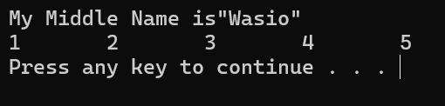
Output

Activity 4
Write a program that displays your favorite poem..
Program
#include<iostream>
using namespace std;
int main(){
cout<<"\t\t\'A NEW DAWN\'";
cout<<"\n\tThe sun awakens with golden light,";
cout<<"\n\tChasing away the fading night.";
cout<<"\n\tWhispers of wind in branches play,";
cout<<"\n\tGuiding the dawn of a brand-new day.";
cout<<"\n\tDreams take flight on skies so blue,";
cout<<"\n\tEach morning brings a hope thats new.\n";
system("pause");
return 0;

}
Output
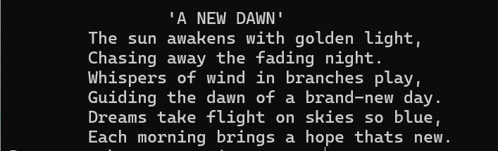

Activity 5 (Box)
Write a program to print a box, an arrow of asterisks using escape sequences:
Program
#include<iostream>
using namespace std;
int main(){
cout<<" **********";
cout<<"\n *\t *";
cout<<"\n\n *\t *";
cout<<"\n\n *\t *";
cout<<"\n\n *\t *";
cout<<"\n\n *\t *";
cout<<"\n\n *\t *";
cout<<"\n\n *\t *";
cout<<"\n **********"<<endl<<endl;
system("pause");
return 0;
}
Output
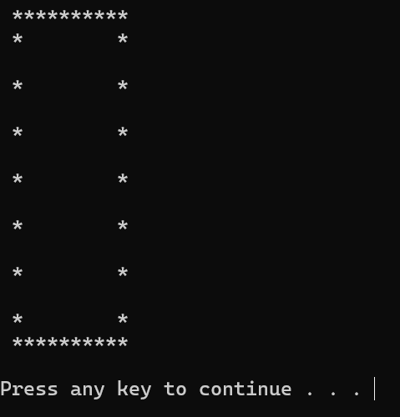

Activity 5 (Arrow)
Write a program to print a box, an arrow of asterisks using escape sequences:
Program
#include<iostream>
using namespace std;
int main(){
cout<<" *";
cout<<"\n ***";
cout<<"\n *****";
cout<<"\n *";
cout<<"\n *";
cout<<"\n *";
cout<<"\n *";
cout<<"\n *";
cout<<"\n *\n";
system("pause");
return 0;
}
Output
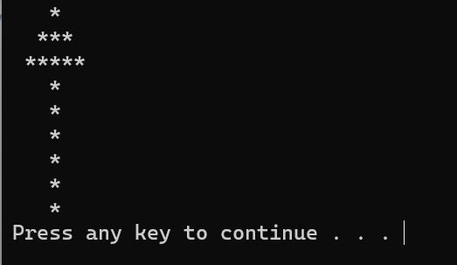

Exercise 1
Write a program that displays the triangle pattern using a single output statement using escape sequences.
Program
#include<iostream>
using namespace std;
int main(){
cout<<"*\n"<<"* *"<<"\n* * *"<<"\n* * * *\n";
system("pause");
return 0;
}

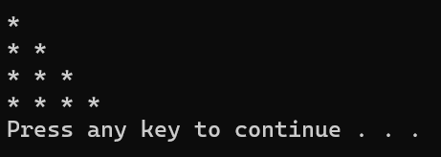
Output

Exercise 2
Write a program that displays the following output:
‘D’ ‘I’ ‘g’ ‘e’ ‘s’ ‘t’
“Programming”.
Program
#include <iostream>
using namespace std;
int main(){
cout<<"'D'\t\'i\'\t\'g\'\t\'e\'\t\'s\'\t\'t\'\t"<<"\n\"Programming\"";
return 0;

}
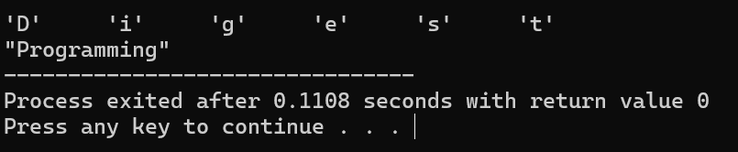
Output

Exercise 3
Write a program that displays the arrowhead pattern using a single output statement using escape sequences.
Program
#include<iostream>
using namespace std;
int main(){
cout<<"*\n*\t*\n*\t*\t*\n*\t*\n*\n";
system("pause");
return 0;
}
Output
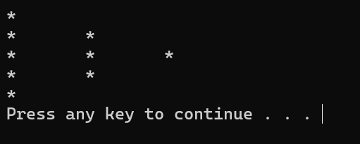

Exercise 4
Write a program that displays the 5×2 matrix using a single output statement using escape sequences.

Program
#include <iostream>
using namespace std;
int main() {
cout << "*******Here is 5x2 Matrix*******:\n\n";
cout << "1\t2\n";
cout << "3\t4\n";
cout << "5\t6\n";
cout << "7\t8\n";
cout << "9\t10\n";
return 0;
}
Output
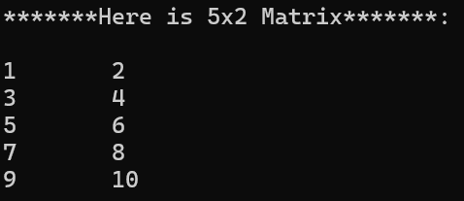

Exercise 5
Write a program that displays a square, a cube of a number by multiplying numbers twice or thrice respectively in table form using escape sequences.

Program
#include<iostream>
using namespace std;
int main(){
int a=1,b=2,c=3,d=4;
cout<<"Value\tSquare\t Cube\n";
cout<<a<<"\t "<<(a*a)<<"\t "<<a*a*a<<endl;
cout<<b<<"\t "<<(b*b)<<"\t "<<b*b*b<<endl;
cout<<c<<"\t "<<(c*c)<<"\t "<<c*c*c<<endl;
cout<<d<<"\t "<<(d*d)<<"\t "<<d*d*d<<endl;
system("pause");
return 0;
}
Output
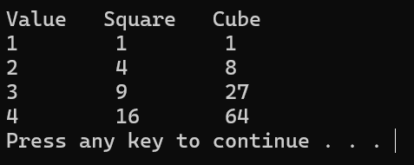

!! Note: Some Programs will give some different Output (Spacing Issue) in different software’s due to Complier.

Exercise 6
Write a program to print a diamond using escape sequences.

Program
#include <iostream>
using namespace std;
int main(){
cout<<"\t *";
cout<<"\n\t ***";
cout<<"\n\t *****";
cout<<"\n\t*******";
cout<<"\n *********";
cout<<"\n ***********";
cout<<"\n *************";
cout<<"\n ***************";
cout<<"\n *****************";
cout<<"\n *******************";
cout<<"\n *********************";
cout<<"\n***********************";
cout<<"\n *********************";
cout<<"\n *********************";
cout<<"\n *******************";
cout<<"\n *****************";
cout<<"\n ***************";
cout<<"\n *************";
cout<<"\n ***********";
cout<<"\n *********";
cout<<"\n\t*******";
cout<<"\n\t *****";
cout<<"\n\t ***";
cout<<"\n\t *";
return 0;

}
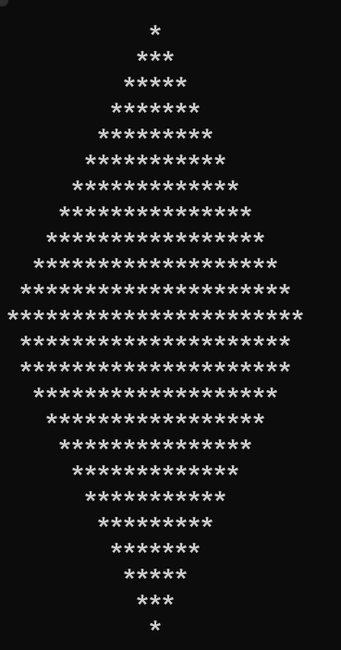
Output

Exercise 7
Write a program to print your first name with stars (*) using escape sequences.

Program
#include<iostream>
using namespace std;
int main(){
cout<<"********\n*SHAIKH*\n********";
return 0;
}
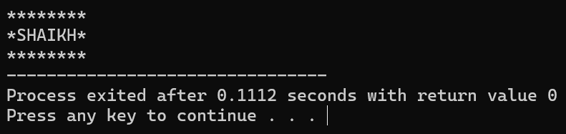
Output

Exercise 8
Write a program to print an oval of asterisks using escape sequences.

Program
#include <iostream>
using namespace std;
int main(){
cout<<"\t***";
cout<<"\n\n * *";
cout<<"\n\n * *";
cout<<"\n\n * *";
cout<<"\n\n * *";
cout<<"\n\n * *";
cout<<"\n\n\t***";
return 0;
}

Output


Exercise 9
Write a program that displays the pattern of asterisks shown below using escape sequences.

Program
#include<iostream>
using namespace std;
int main(){
cout<<"\t*";
cout<<"\n * *";
cout<<"\n * *";
cout<<"\n * *";
cout<<"\n * *";
cout<<"\n * *";
cout<<"\n * *";
cout<<"\n * *";
cout<<"\n * *";
cout<<"\n\t*";
return 0; }
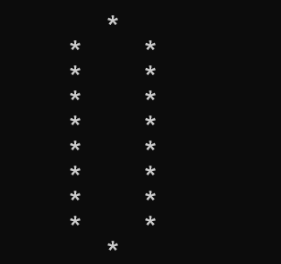
Output

Exercise 10
Write a program that displays the triangle pattern using a single output statement using escape sequences.
Program
#include<iostream>
using namespace std;
int main(){
cout<<"\t*";
cout<<"\n * *";
cout<<"\n * *";
cout<<"\n * *";
cout<<"\n * *";
cout<<"\n *************";
return 0;
}

Output
